Session 5 - Assignment 6 >

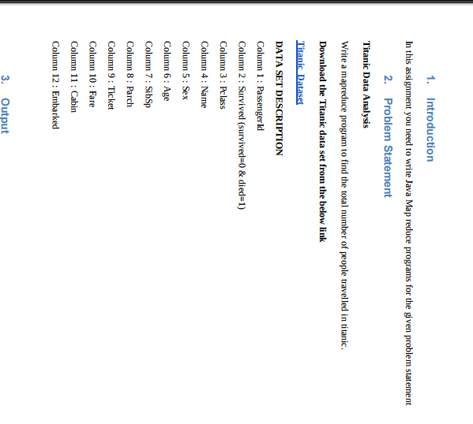

As we need to find the number of people travelled in titanic for that we need not to split, we have to count every passenger id, so our respective java code is :

Codes :

Driver Class:

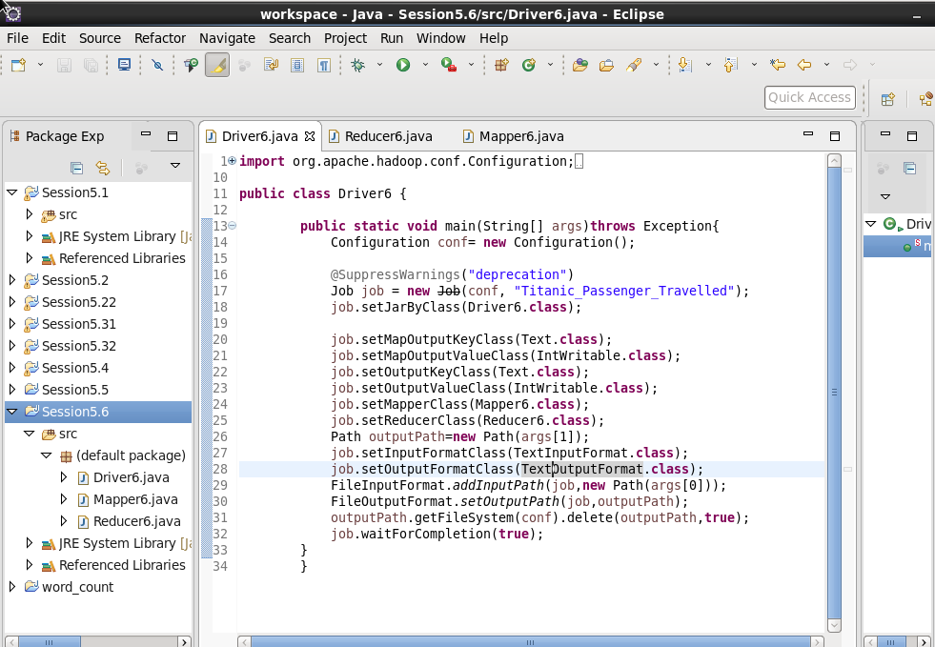

Mapper Class:

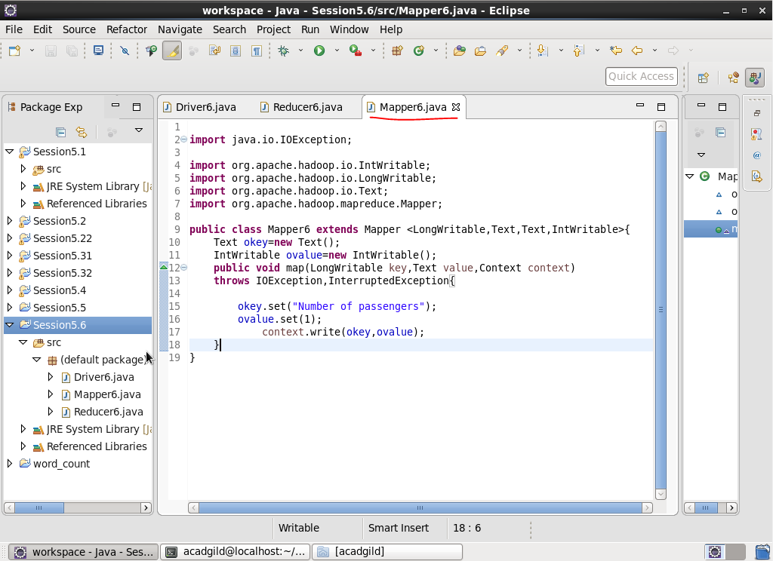

Reducer Class :

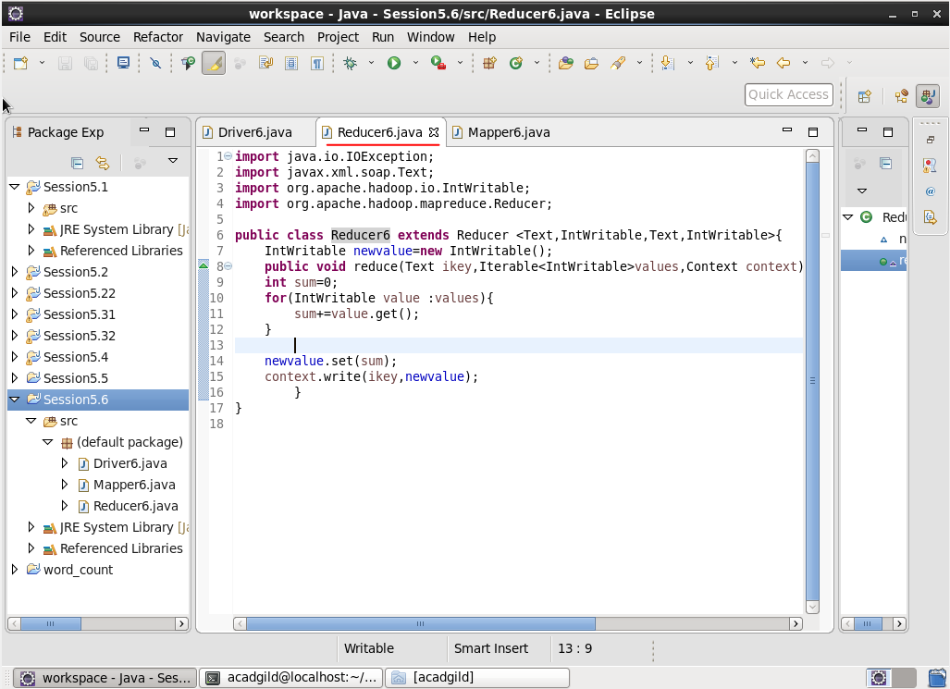

Input :

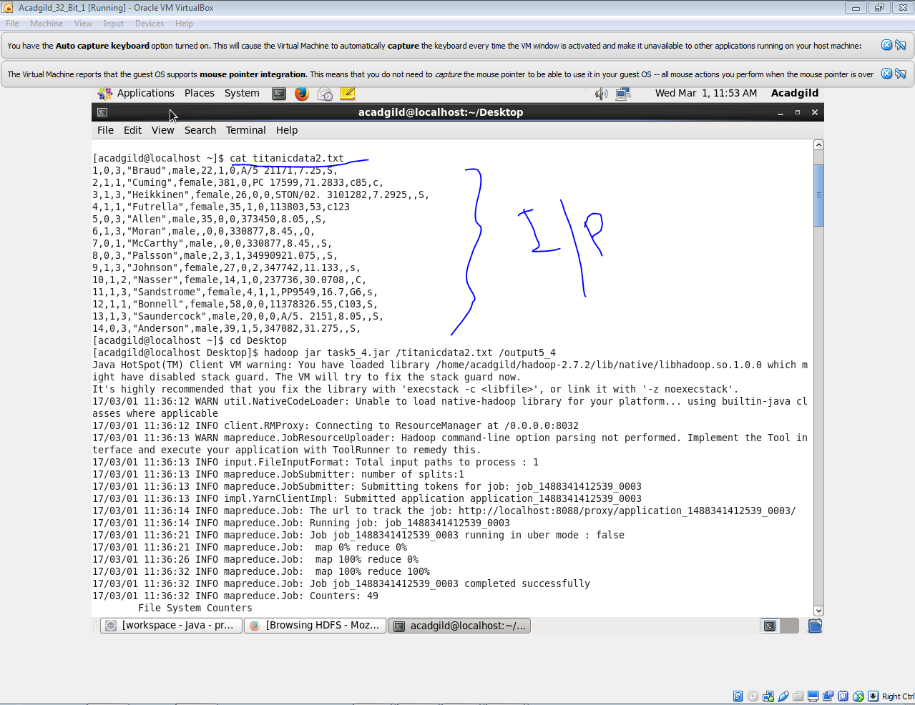

Output :

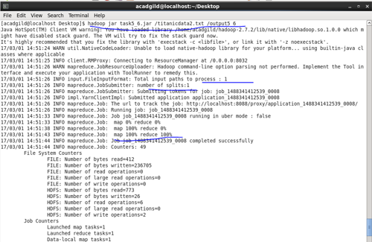

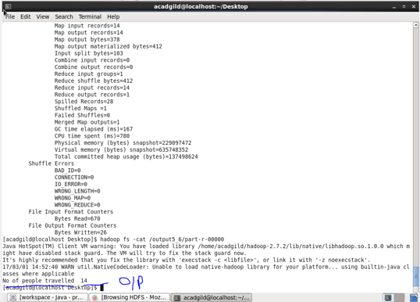

So we found that : According to our database total 14 passengers travelled.